Branding:

Font :

Kefa – Regular

Colors:

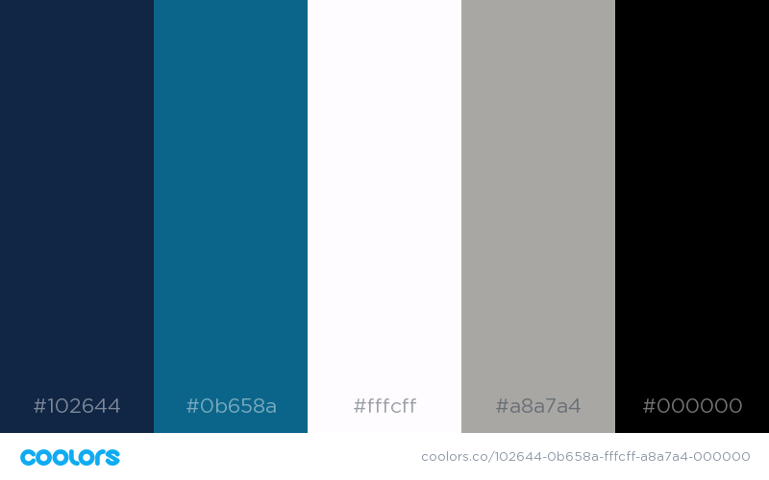

Logos:

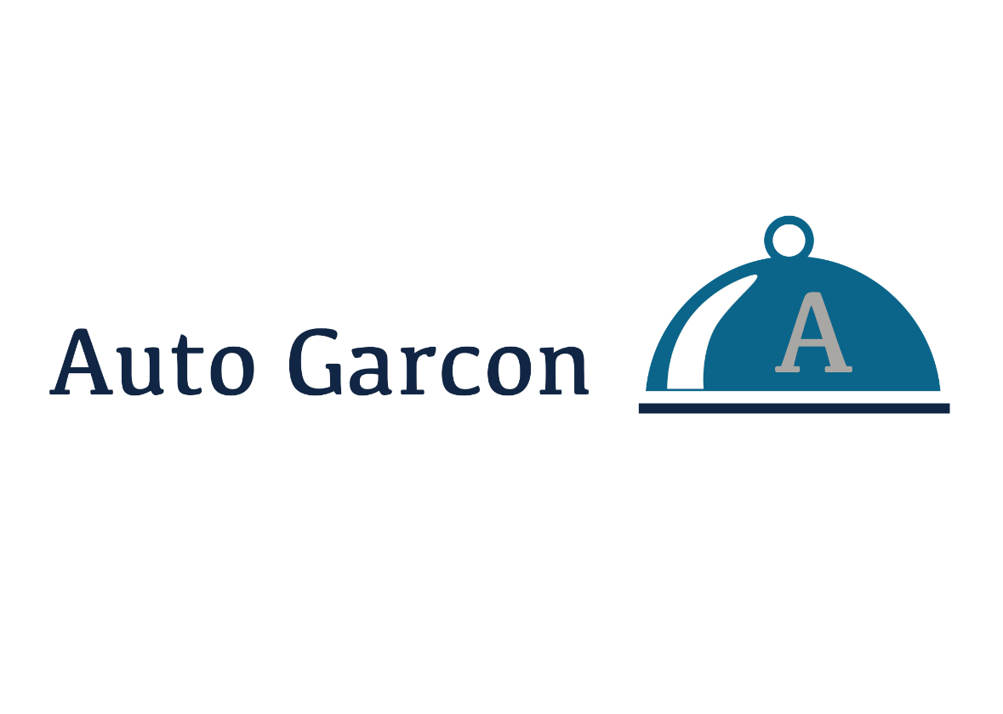[https://raw.githubusercontent.com/bricao16/AutoGarcon/master/Style Guides/Colors.png](https://raw.githubusercontent.com/bricao16/AutoGarcon/master/Style%20Guides/Colors.png)